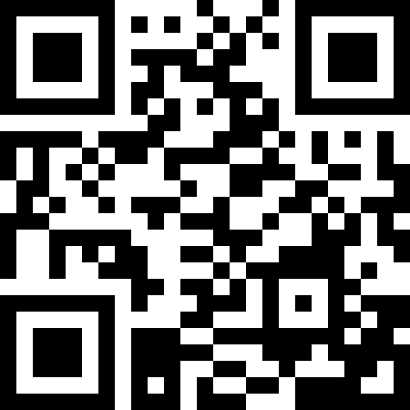
Week 6
Task 1
- Post your project to flipgrid using the QR code or the link https://flipgrid.com/6fa23759
- Watch at least 3 classmates videos and leave a comment that explains one thing new you learned about Australia from their video. Please use complete sentences.

Task 2
- Watch the video: what is a time capsule?
- Read over the Covid-19 Time Capsule Project. Please write down any questions you have so that I can answer them during our Zoom session (Wednesday at 10AM for all classes).
- Begin working on the project completing pages 1- 4
- Write journal and collect artifacts for time capsule

Task 3
- Complete Pages 5 and 6 of your Time Capsule
- Write journal and collect artifacts for time capsule

Please note: the Coronavirus Project is due on May 11th. Feel free to complete it the way I am pacing you, or to work ahead.

