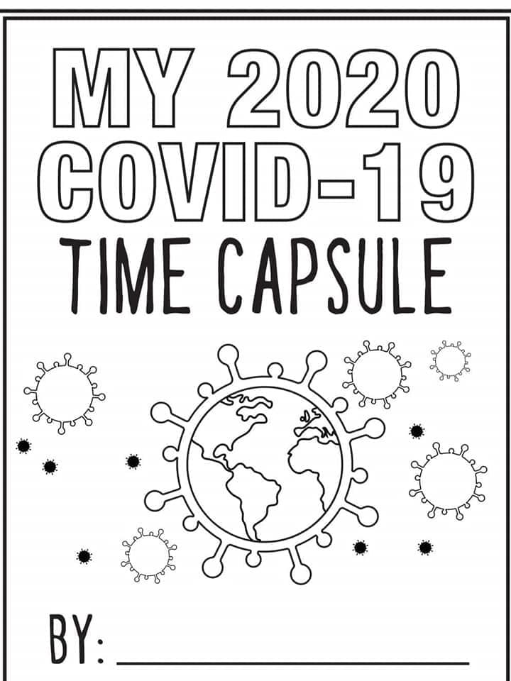

YOU are living in a historically significant time. Life as we know it is changing and may never be the same after the Coronavirus Pandemic. The goal of the Covid – 19 Time Capsule assignment is to help you process what we are going through, as well as to connect it to what we have learned in social studies this year. As I have stated, EVERY problem is a social studies problem. Thus, Coronavirus is no different.
This project may serve as a keepsake that you save for many years. We are creating PRIMARY source documents so that historians will have an accurate picture of what life was like during the pandemic.
Student Directions: Your job is to chronicle the changes you observe as your community, the country, and the world respond to Covid19. Each day, take note of what you are seeing and hearing on the news, among your friends, within your family, and in your community. Feel free to use video, written language, poetry, sketches, or other means of expression as you document your experience during this global pandemic.

Project Requirements
- Complete all prompts/pages included. Make sure all pictures are done neatly and preferably in color.
- Take at least 5 photos or create 5 pieces of art work that illustrate the impact Coronavirus has had on your and your family. Create a caption that explains the photo.
- Find a minimum of two news articles related to Coronavirus and include them in your time capsule. Write a paragraph for each article explaining how the news article made you feel.
- Include at least (3) journal entries of one paragraph or more each. In these journal entries, describe what life was like for you that day.
- Most of all – have fun! You are creating a primary source that you will hold on to for time to come. It is important that we document and reflect on the changes that are happening in real time.

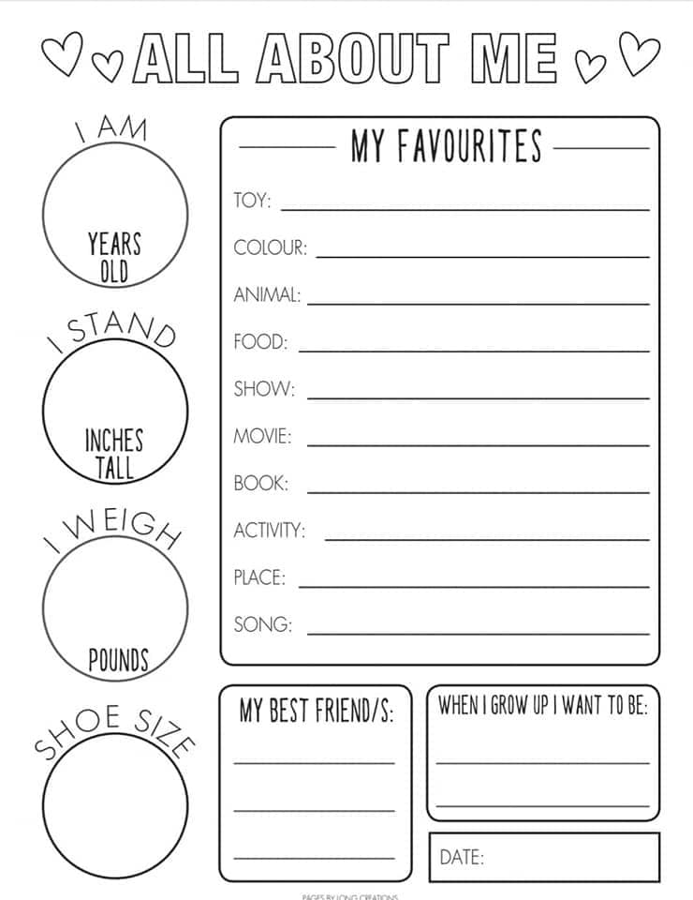
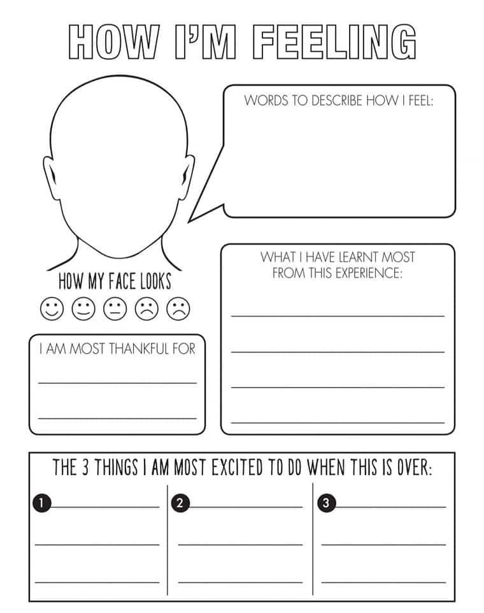

- Draw a map of your neighborhood. You can choose the scale. Include a key or legend so readers know what you are referring to. You might want to consider adding items such as places you walk, exercise, grocery store your family goes to, family nearby. OR, you can simply create a map of your home and include items such as your room, tv, the fridge, back porch, etc.

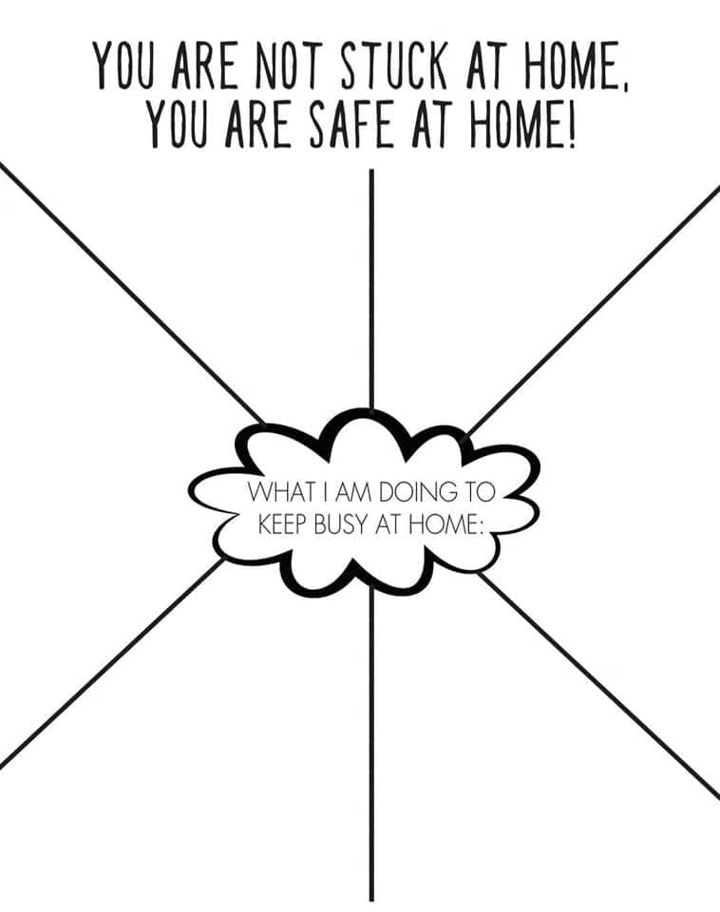
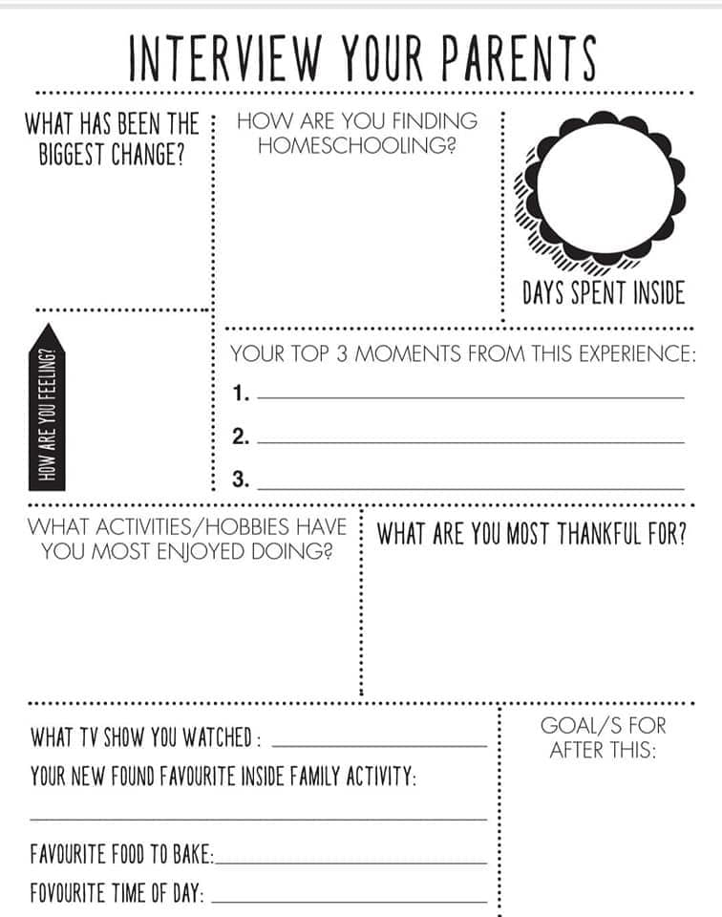
** You may choose to interview a sibling, grandparent, or neighbor instead of your parents.

Reflect: How does what we learned in class this year apply to the Coronavirus? Draw a picture and write 2-3 sentences explaining how Coronavirus connects to a key social studies concept.
Economics | Government
History | Geography
Key Concept Examples
Economics  Supply  Demand  Scarcity  Market Economy  Command Economy  Risk  Savings  Expenditures  Currency  Regulations  Trade  Production, Consumption, Distribution | Government  Regulations  Vote  Democracy  Power  Legislature  Voice  Community  Subsidies  Equality  Justice
History  Time, change, and continuity  Change over time | Geography  Location  Climate  Natural Resources  How does where you live impact how you live?  Human-Environmental Interaction

Attach the Following
- Take at least 5 photos or create 5 pieces of art that illustrate the impact Coronavirus has had on your and your family. Create a caption that explains the photo.
- Find a minimum of two news articles related to Coronavirus and include them in your time capsule. Write a paragraph for each article explaining how the news article made you feel.
- Include at least (3) journal entries of one paragraph or more each. In these journal entries, describe what life was like for you that day.
  - Questions to consider when journaling….
- What did the government announce/declare/implement today?
  - Does it make sense?
  - Does it impact your life? Why or why not?
  - How did your family respond?
- What is open in your neighborhood? What is closed?
What does your neighborhood look like? Are people walking around?
- How is today different from yesterday for you, your family, our nation, the world?
- Do you see any examples of racism, privilege, and income inequality in any of the events that happened today? (Locally, at the state level, nationally, or the world?)
- Did you see anything today that gave you hope? Anxiety? Fear? (In person, in the news, or on social media?)
- What does your family need today that you might not have, have enough of, or have no access to acquire?
- What do you and your family have that others may need?

Note: If you do not have a printer, feel free to complete this on your own paper. Simply include the same information, You will not be penalized for this!

***To turn in this project, you will make a presentation and scan or take pictures of your work and turn it in to ms. Delhey****

